📘 IAM User & Role Management Documentation (AWS)

✅ Prerequisites
- AWS Account (Root access initially)
- IAM permissions:
  - iam:* (for admin setup)

🔐 1. Create IAM Users
Steps:
- Login to AWS Management Console
- Navigate to IAM → Users
- Click “Create user”
- Enter:
  - User name
- 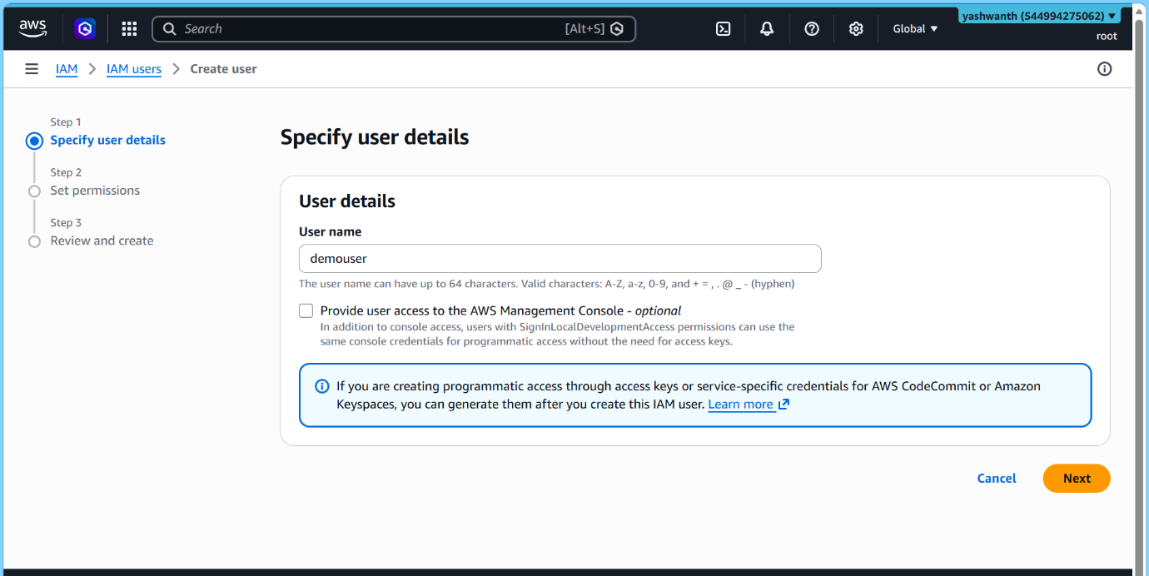

- Select access type:
  - ✅ AWS Management Console access (for UI login)
  - ✅ Programmatic access (for CLI/API)

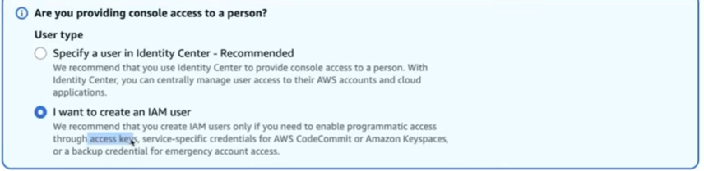

- Set password:
  - Auto-generated or custom
  - Enforce password reset (recommended)
- Click Next

🔗 Assign Permissions
Choose one of the following:
- ✅ Add user to group (Recommended)
- Attach policies directly (not preferred)
- 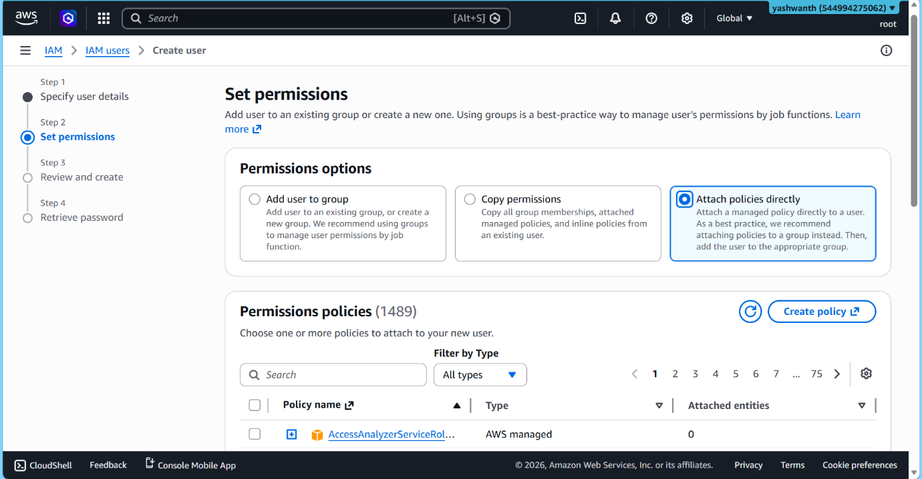

👤 Review & Create
- Verify settings
- Click Create user
- Download:
  - Credentials
  - Access keys (if created)

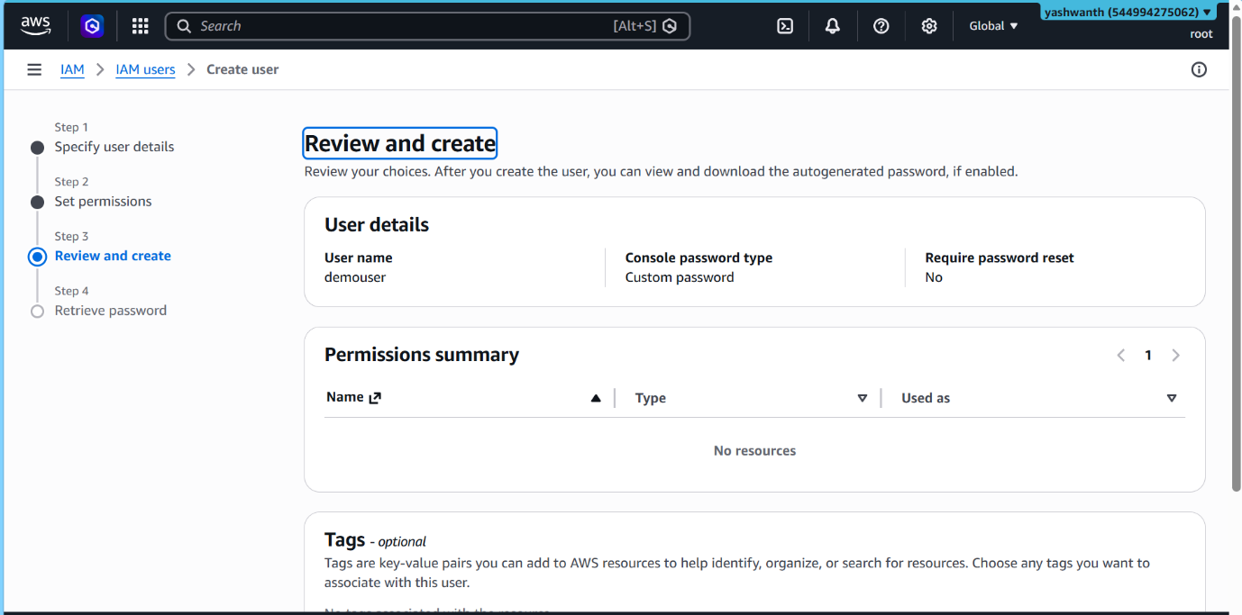
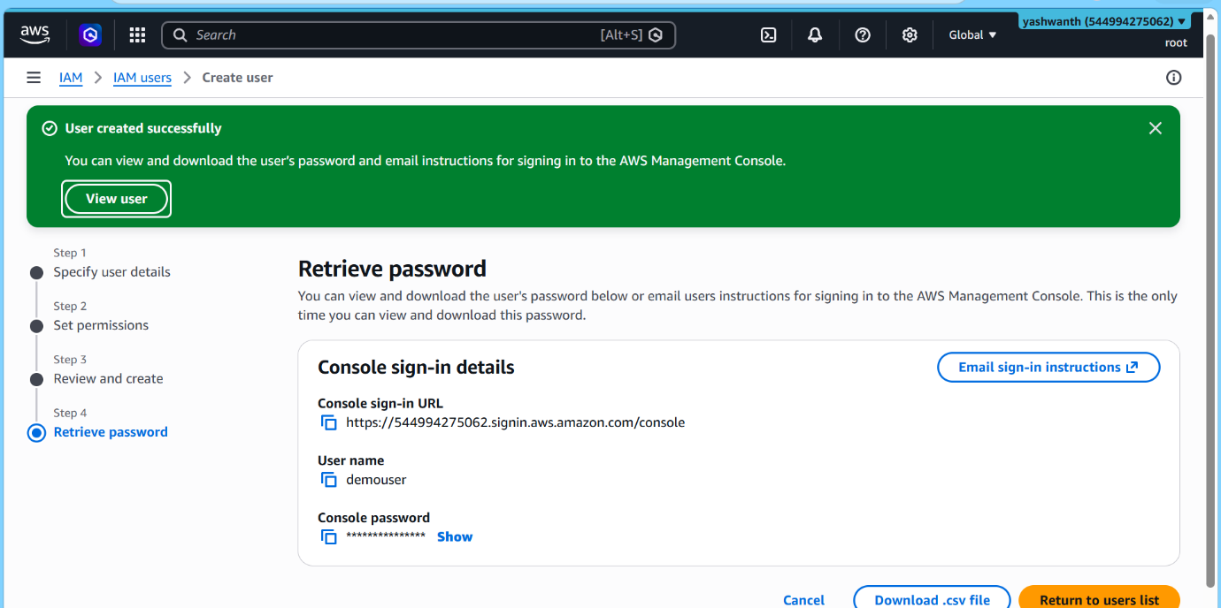

👥 2. Create IAM Groups
Steps:
- Go to IAM → User Groups
- Click “Create group”
- Enter:
  - Group name (e.g., Developers, Admins)
- Attach permissions (policies):
  - Example:
    - AdministratorAccess
    - AmazonEC2ReadOnlyAccess
- Click Create group

➕ Add Users to Group
- Open the group
- Click Add users
- Select users
- Click Add users

📜 3. Create IAM Policies
Steps:
- Navigate to IAM → Policies
- Click Create policy
- Choose:
  - ✅ Visual editor (easy way)
  - ✅ JSON (advanced)

🧩 Example Policy (S3 Read-only)
JSON
{
"Version": "2012-10-17",
"Statement": [
{
"Effect": "Allow",
"Action": ["s3:Get*", "s3:List*"],
"Resource": "*"
}
]
}
Show more lines

Save Policy
- Click Next
- Name the policy
- Add description
- Click Create policy

🔗 Attach Policy
- Go to:
  - User / Group / Role
- Click Add permissions
- Attach created policy

🔐 4. Enable Multi-Factor Authentication (MFA)
Steps:
- Go to IAM → Users
- Select user
- Click Security credentials tab
- Under MFA → Click Assign MFA device

Choose MFA Type:
- ✅ Virtual MFA (Google Authenticator, Microsoft Authenticator)
- ✅ Hardware MFA

Setup Process:
- Scan QR code with authenticator app
- Enter two consecutive codes
- Click Assign MFA

✅ Best Practices:
- Enforce MFA for all users
- Especially for admin accounts

🔄 5. Create IAM Roles
Steps:
- Navigate to IAM → Roles
- Click Create role

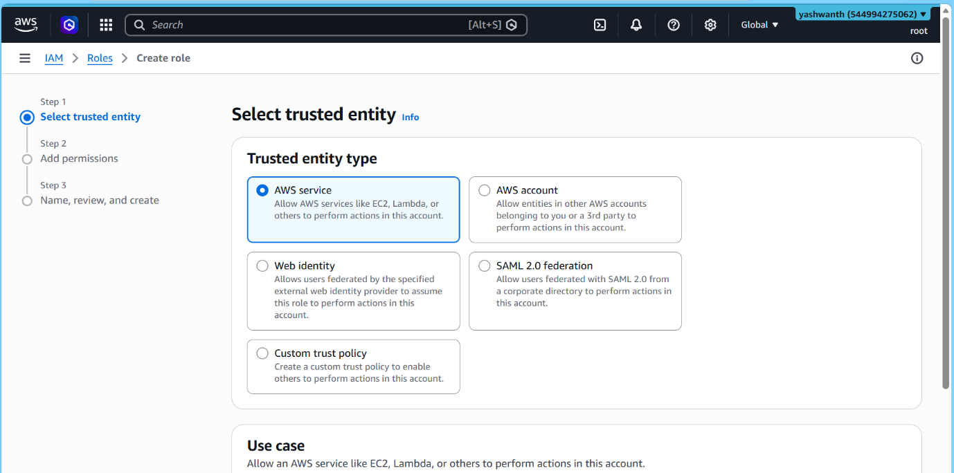

Select Trusted Entity:
Choose based on use case:
- ✅ AWS Service (EC2, Lambda)
- ✅ Another AWS account
- ✅ Web identity (OAuth, SAML)

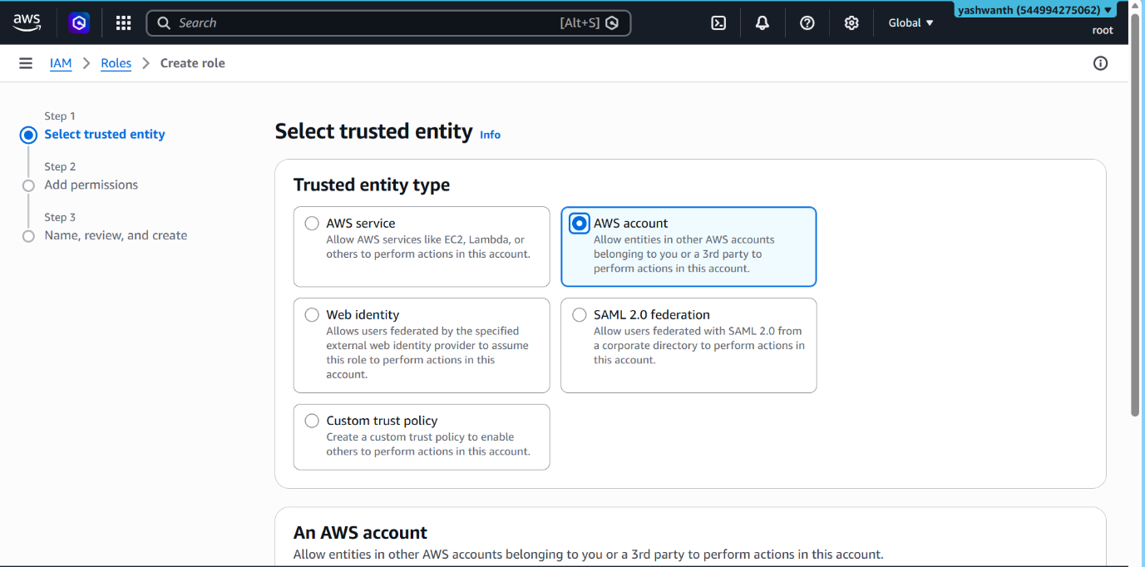
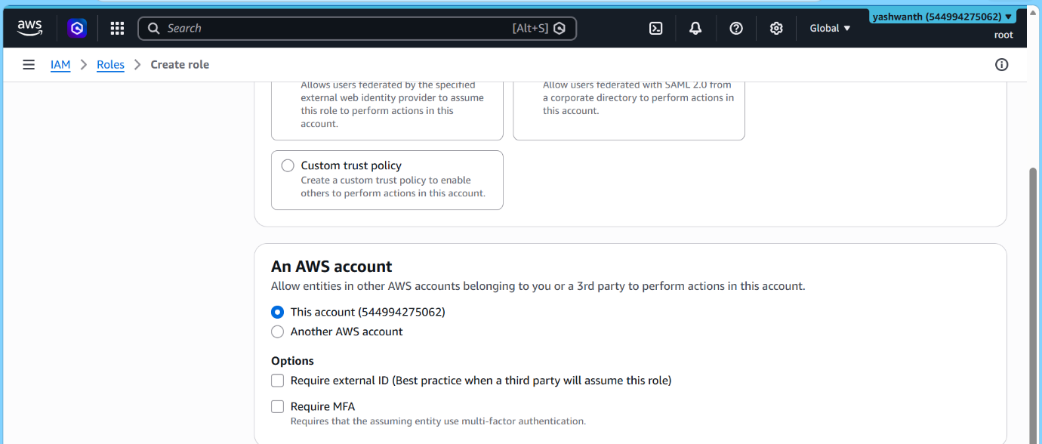

Example: EC2 Role Creation
- Select AWS Service
- Choose EC2
- Click Next

Assign Permissions:
- Attach policy (e.g., AmazonS3ReadOnlyAccess)

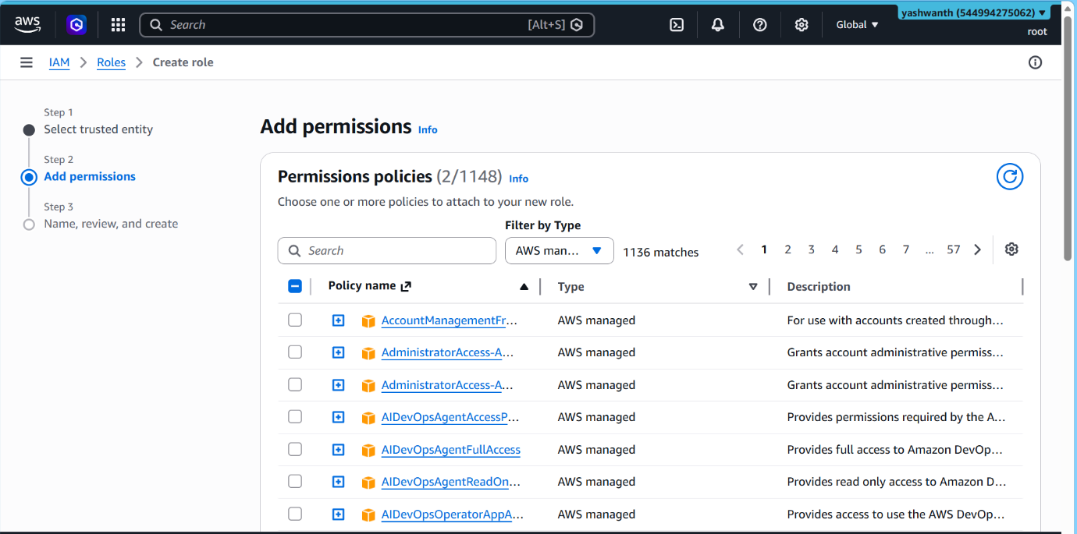

Finalize:
- Enter role name
- Click Create role

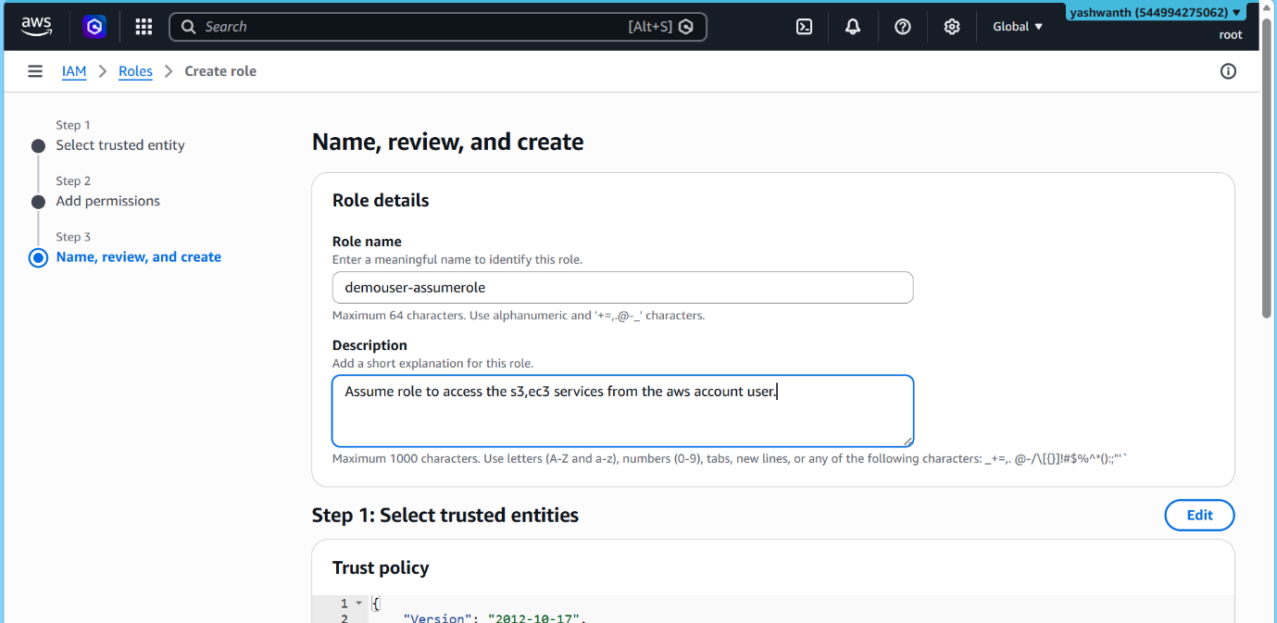

🔗 Attach Role to EC2 Instance
Steps:
- Go to EC2 → Instances
- Select instance
- Click:
  - Actions → Security → Modify IAM Role
- Select created role
- Save

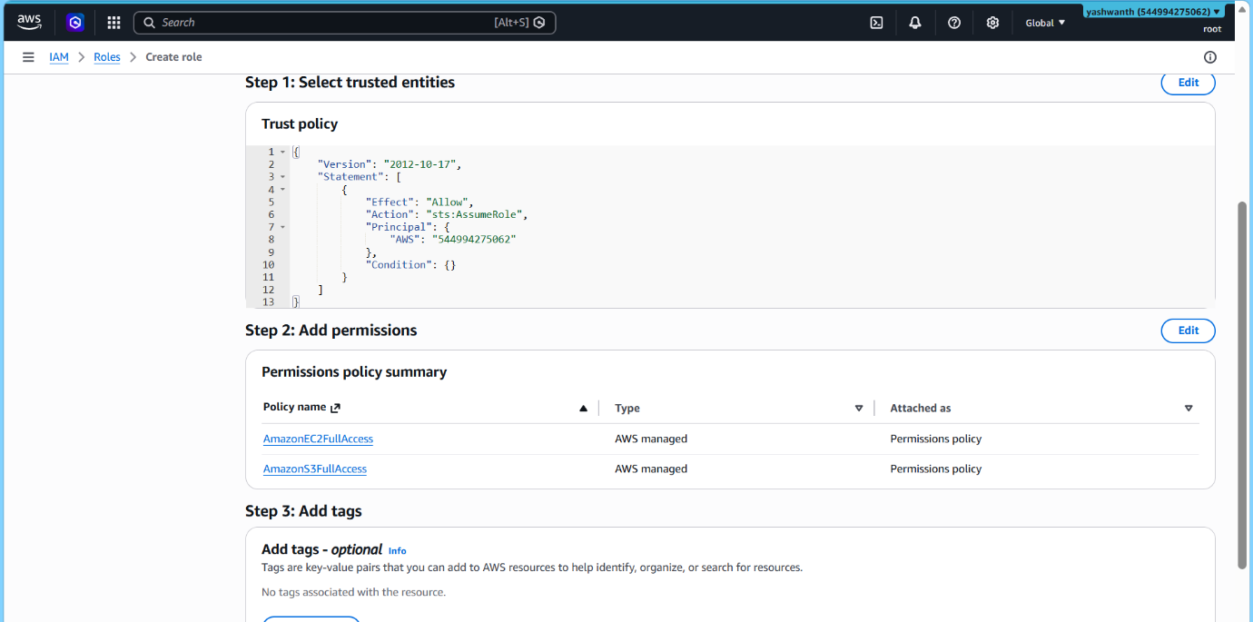

🔒 6. IAM Security Best Practices
- ✅ Never use root account for daily tasks
- ✅ Enable MFA for root & IAM users
- ✅ Use groups instead of individual policies
- ✅ Follow least privilege principle
- ✅ Rotate access keys regularly
- ✅ Enable CloudTrail logging
- ✅ Use roles instead of sharing credentials

